Lab08

Nguyen Nam Tung 103181157

8.1.

8.2.

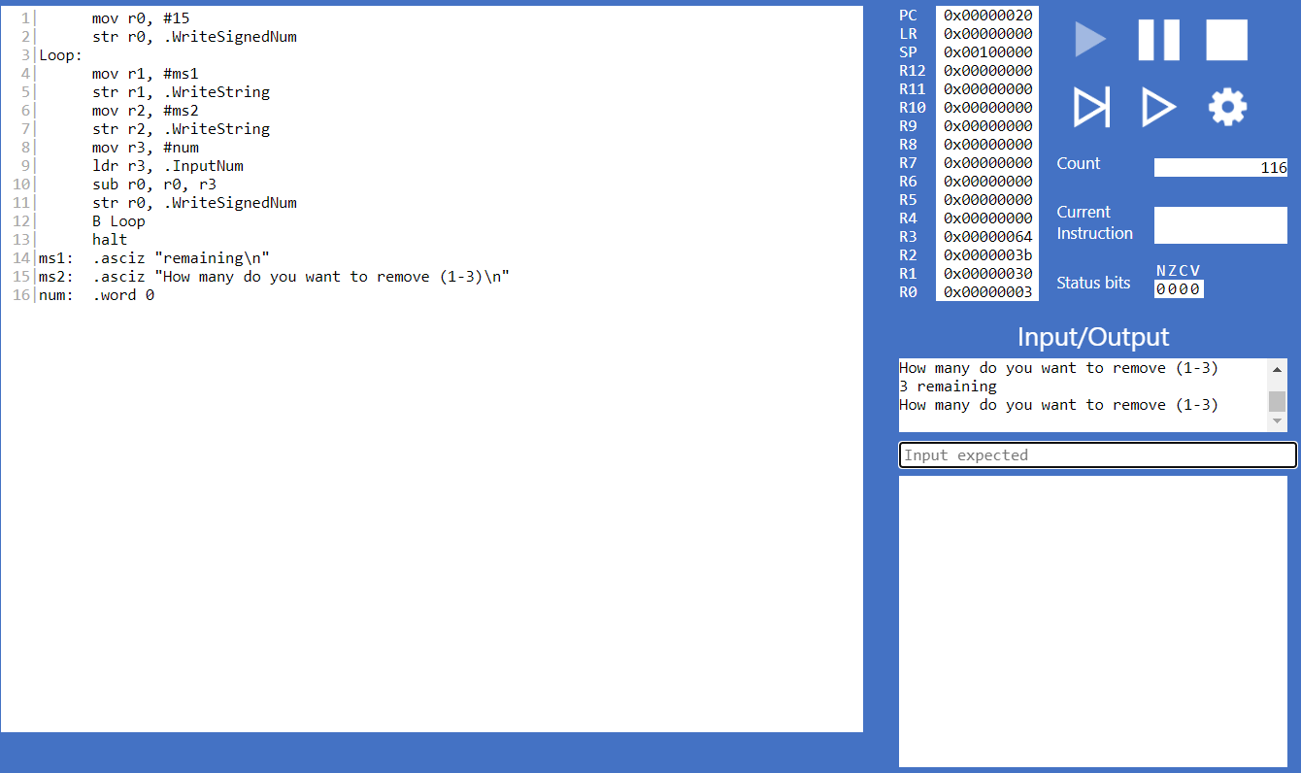

The values entered must be between 1 and 3

* We can use CMP and BLT

8.2.2

N and Z bit should be set to 1 if the instruction is executed. Otherwise, when the entered value is less than 3, only N bit is set, as we compared the entered value with 3, so the result in this case will obviously negative.

Full Code

mov r0, #15

Loop:

str r0 ,.WriteSignedNum

mov r1 ,#ms1

str r1 ,.WriteString

mov r2, #ms2

B Loop2

select:

str r0 ,.WriteSignedNum

mov r1 ,#ms1

str r1, .WriteString

mov r7 , #ms4

str r7 , .WriteString

select_again:

LDR R6, .Random

AND R6, R6, #3

CMP R6, #0

BGT select2

B select_again

select2:

CMP R6 , R0

BGT select

SUB R0 , R0 , R6

CMP R0, #0

BEQ prompt1

BGT Loop

prompt1:

mov r12, #ms5

str r12, .WriteString

halt

prompt2:

mov r12, #ms6

str r12, .WriteString

halt

Loop2:

str r2, .WriteString

mov r3, #num

ldr r3, .InputNum

cmp r3 , #1

blt Loop2

b condition1

condition1:

cmp r3, #3

bgt Loop2

b condition2

condition2:

sub r0 , r0 , r3

cmp r0 , #0

beq prompt2

bgt select

mov r5, #ms3

str r5, .WriteString

halt

ms1: .asciz "remaining\n"

ms2: .asciz "How many do you want to remove (1-3)?\n\n"

ms3: .asciz "There are no sticks left!\n"

ms4: .asciz "___Computer Turn___\n"

ms5: .asciz "\nWin \n\n "

ms6: .asciz "\nLose\n\n"

num: .word 0